HBM, Test and Measurement Expert from Darmstadt, Germany, Invests in Production and Logistics Center
- Test and measurement expert HBM is building a new production and logistics center to further strengthen its Darmstadt headquarters
- 6000 m² of usable space for the company
- Laying of the foundation stone on August 3, 2016 with the participation of Jochen Partsch, Mayor of Darmstadt

Darmstadt, August 3, 2016. Building a new production and logistics center and expanding office space at its Darmstadt headquarters, test and measurement expert HBM (Hottinger Baldwin Messtechnik) has set the course for further growth. At the ceremonial laying of the foundation stone, Jochen Partsch, Mayor of Darmstadt, praised the commitment of the technology company.
“HBM ranks as a so-called ‘hidden champion’, a world market leader in test and measurement headquartered in Darmstadt”, Mayor Jochen Partsch acknowledges the role of the company. He goes on to say: “I am very pleased that HBM came to the conclusion that: Darmstadt is our home base; from here we will continue to conquer the world’s markets and from here we will build a bright future for HBM.”

Founded in 1950, HBM is today a global technology company with production and development sites and distribution companies in over 30 countries throughout the world. The headquarters in Darmstadt, with its staff of 750, continues to be the backbone of the company: It is the development and production center.

With the new building, the company has set the course for further growth. “We feel at home here in Darmstadt”, says HBM CEO Andreas Hüllhorst. “The double-digit investment is a commitment to HBM’s future and its headquarters in Darmstadt. The new building creates 6000m² of usable space for our company”, explains Andreas Hüllhorst.
“Besides space for the production of heavy-duty and torque sensors - we are the clear technology and market leaders in these product lines - we are creating the prerequisites for efficient logistics and modern office space with close links to the production”, says Karl-Heinz Pöhlmann, Vice President Supply Chain.

The transparent design of the entire building highlights HBM’s core values such as precision, innovative capacity and reliability. Visitors will be able to take a look at the production facilities visible to the public. Ruby³ architects from Darmstadt designed the building and are responsible for construction management. The move-in date is set for the end of 2017 already.
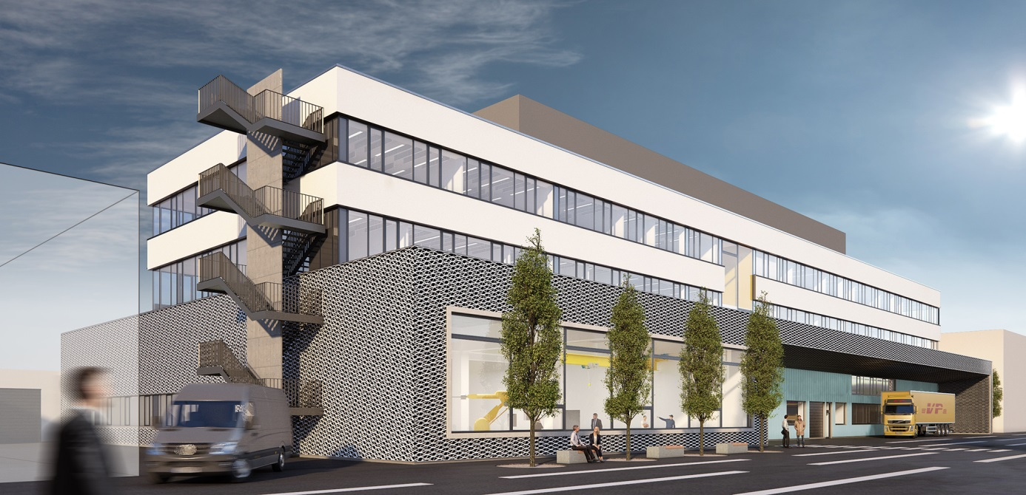
Figure 1: The new production and logistics center at HBM’s Im Tiefen See company premises. Completion scheduled for the end of 2017. Photo: Ruby³ architects
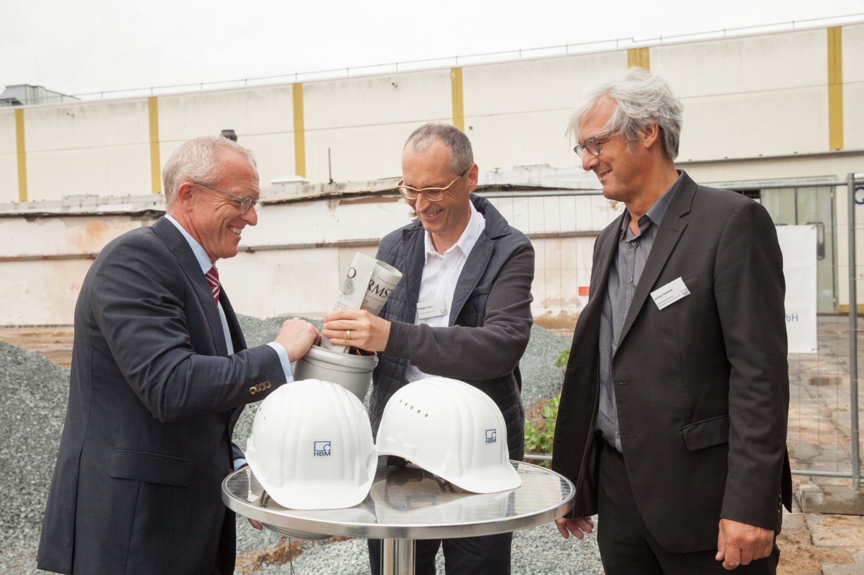
Figure 2: An HBM load cell, a current daily newspaper and the latest HBM company brochure were put into a “time capsule”. From left to right: Andreas Hüllhorst, HBM CEO; Rüdiger Ruby, architect of the new building; Jochen Partsch, Mayor of Darmstadt. Photo: Melanie Niesik
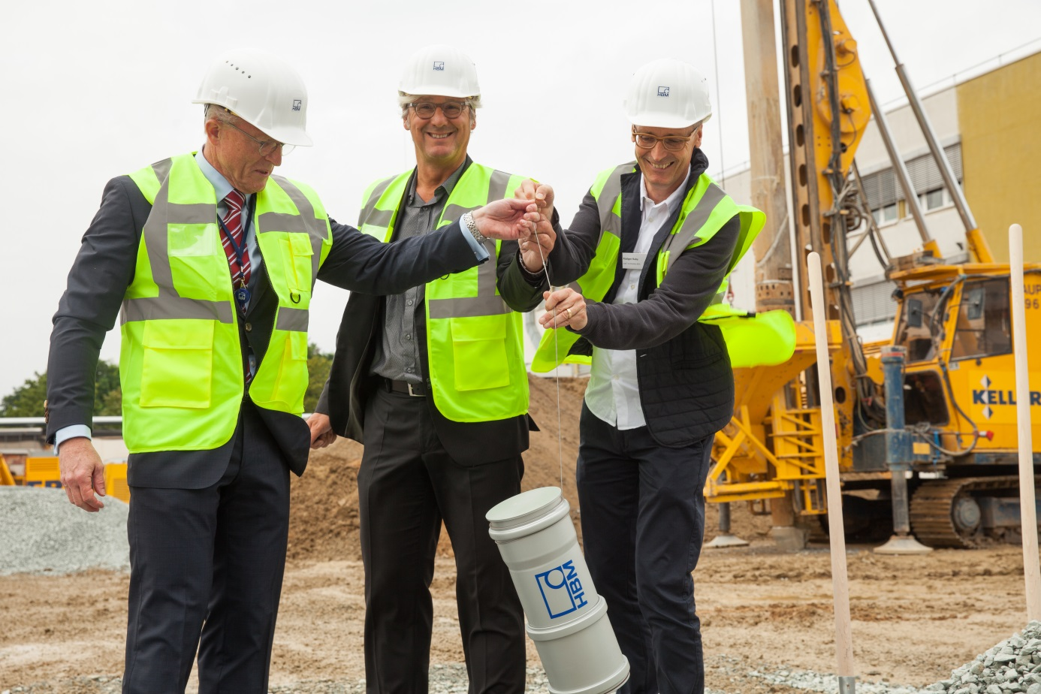
Figure 3: The time capsule was lowered into the ground as a lucky charm for the new building. From left to right: Andreas Hüllhorst, HBM CEO; Jochen Partsch, Mayor of Darmstadt; Rüdiger Ruby, architect of the new building. Photo: Melanie Niesik
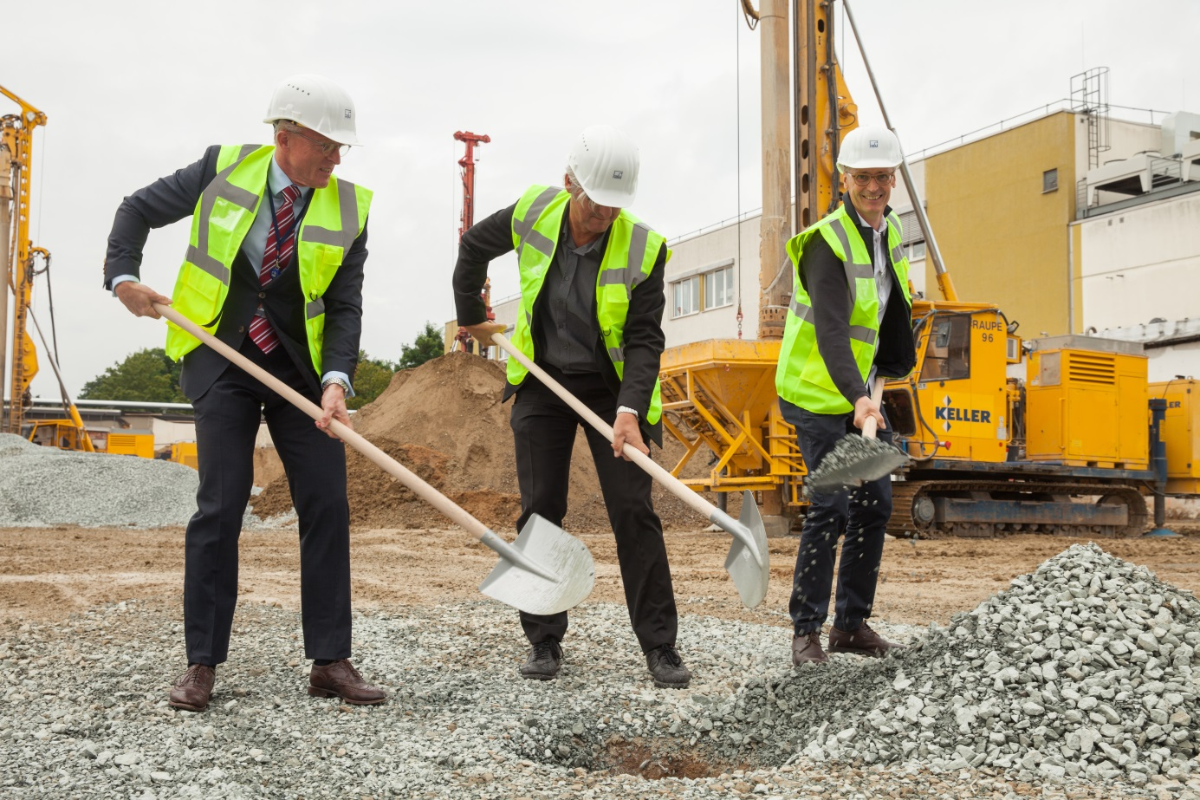
Figure 4: Andreas Hüllhorst, HBM CEO, Jochen Partsch, Mayor of Darmstadt and architect Rüdiger Ruby (from left to right) at the ceremony marking the building of the new production and logistics center. Photo: Melanie Niesik
You will find the pictures for download at www.hbm.com/presse.

HBM Test and Measurement
Founded in Germany in 1950, Hottinger Baldwin Messtechnik GmbH (HBM) is today the technology and market leader in the field of test and measurement. HBM’s product range comprises solutions for the entire measurement chain, from sensors through electronics to analysis and simulation software as well as associated services. The company has production facilities in Germany, USA, China and Portugal and is represented in over 80 countries worldwide. HBM currently employs a total of 1,800 staff.

Contact:
Gilbert Schwartmann
Head of Marketing Communications
Tel. +49/6151/803-109 / gilbert.schwartmann@hbm.com

