New Webinars on Structural Health Monitoring
- HBM offers two new and free webinars addressing the opportunities offered by “Asset Health Monitoring” of infrastructures
- The prerequisite for efficient “Predictive Maintenance” concepts
- 30 minutes of comprehensive knowledge

Test and measurement expert, HBM, offers two new live webinars in September addressing many different aspects of infrastructure monitoring. Participation is free.
Long-term monitoring solutions (also called Structural Health Management - SHM - or Asset Health Management) are gaining ground in an increasing number of industries. The goal in these applications is to measure fatigue and deformation in materials and infrastructures over a long period of time. This approach enables potential damage to be detected and prevented at an early stage.

HBM test and measurement experts Cristina Barbosa and Dietmar Maicz offer a new webinar entitled “Optimize your Structures with AHM (Asset Health Monitoring) Systems Based on Proven Sensor Technologies” (in English) on September 19, 2016. They present state-of-the-art infrastructure monitoring technology and look into the possibilities of using innovative sensor technology in tunnels, bridges, rails and many other infrastructures.

In addition, another webinar scheduled for September 23, 2016 is dedicated to the opportunities offered by infrastructure monitoring in the wind energy industry.
HBM’s test and measurement webinars provide a comprehensive, 30-minute overview of state-of-the art technology and applications. A chat function enables participants to direct their questions to HBM experts after the presentation.

Other HBM webinar topics in September include: optimal protection of strain gauge measuring points (September 20), residual stress analysis with strain gauges (September 21) and the possibilities of implementing intelligent, automated systems using modern measurement systems (September 22).

Please register at www.hbm.com/webinare.
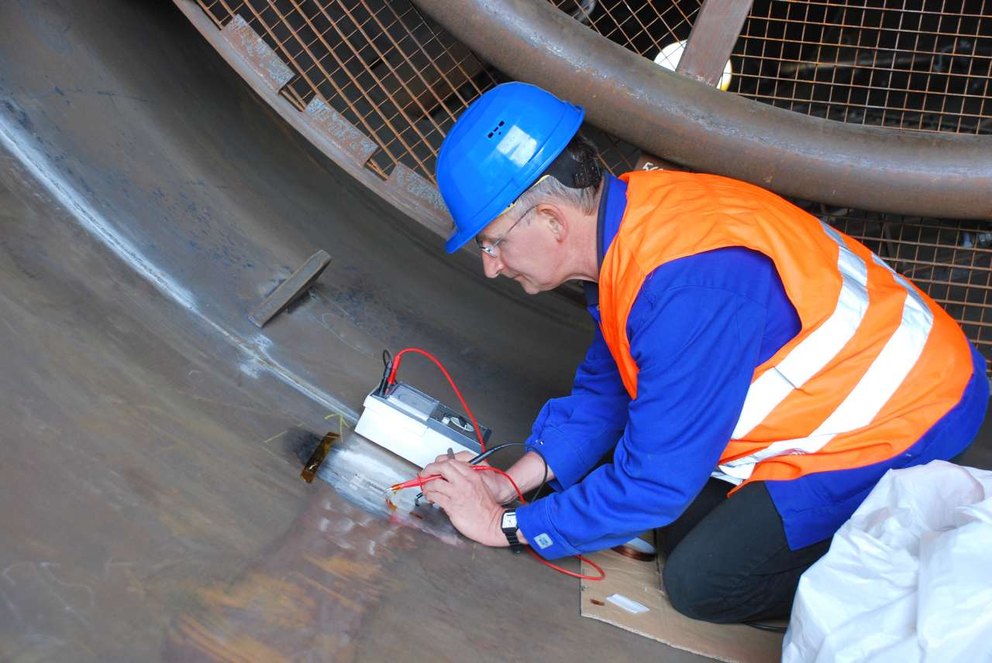
Structural health monitoring solutions are used in many infrastructures. The photo shows the installation of sensors in a wind turbine. Two new HBM webinars look into the possibilities offered by these technologies.

HBM Test and Measurement
Founded in Germany in 1950, Hottinger Baldwin Messtechnik GmbH (HBM) is today the technology and market leader in the field of test and measurement. HBM’s product range comprises solutions for the entire measurement chain, from sensors through electronics to analysis and simulation software as well as associated services. The company has production facilities in Germany, USA, China and Portugal and is represented in over 80 countries worldwide. HBM currently employs a total of 1,800 staff.

Contact:
Gilbert Schwartmann
Head of Marketing Communications
Tel. +49/6151/803-109 / gilbert.schwartmann@hbm.com

