New, Legal-For-Trade Weighing Terminal With PROFINET, EtherNet/IP and PROFIBUS

HBM Test and Measurement´s new legal-for-trade WTX120 weighing terminal provides plant and machine manufacturers with a superior solution for process weighing, filling or sorting.

HBM’s new WTX120 weighing terminal combines the major technical properties of modern weighing electronics with outstanding ease of use. Standard industrial interfaces such as PROFINET, EtherNet/IP and PROFIBUS are available for WTX120. With its maximum resolution of 30,000d (legal for trade: 10,000e), WTX120 is the right choice for all technical and legal needs.

Buttons and an illuminated screen with plain text menus assure total ease of use. WTX120 can be calibrated directly on site, without any additional tools. Mounting on industry-standard rails is easy. The terminal is complemented with PanelX weighing software supporting start-up and servicing.

Moreover, users can benefit from a global world market leader’s many years of experience. HBM offers the complete measuring chain, from the load cell through to electronics and interfaces.

More information at: www.hbm.com/wtx

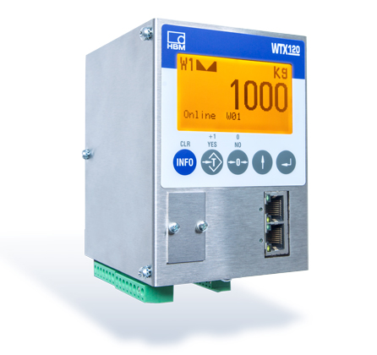

HBM’s new WTX120 weighing terminal provides a large, illuminated screen and buttons for easy start-up or on-site calibration.

HBM Test and Measurement
Founded in Germany in 1950, Hottinger Baldwin Messtechnik GmbH (HBM) is today the technology and market leader in the field of test and measurement. HBM’s product range comprises solutions for the entire measurement chain, from sensors through electronics to analysis and simulation software as well as associated services. The company has production facilities in Germany, USA, China and Portugal and is represented in over 80 countries worldwide. HBM currently employs a total of 1,800 staff.

Contact:
Gilbert Schwartmann
Head of Marketing Communications
Tel. +49/6151/803-109 / gilbert.schwartmann@hbm.com

