New T12HP Torque Transducer Ensures Highly Precise Results over the Entire Measurement Range

- HBM introduces T12HP digital torque transducer for dynamic measurements in test stands
- It has an unparalleled temperature stability (TC0 of 0.005%/10K) and accuracy over the entire measurement range (FlexRange™ function)
- Its highly precise measurement results are an important prerequisite for more efficient drives

The new T12HP digital torque transducer from HBM Test and Measurement (HBM) supports dynamic measurements in the test stand and provides unprecedented precision, particularly in terms of temperature stability. Temperature influences have virtually no impact on the measurement result, due to a TC0 value of 0.005%/10K. In addition, the resulting FlexRange™ function provided by the T12HP allows users to take a closer look at any partial range of the full nominal (rated) measurement range.

The T12HP, therefore, meets the market requirements for increasingly flexible and efficient test cycles; for example, in the development of ever more energy-efficient motors. Due to the T12HP’s integrated and unparalleled high basic accuracy and the resulting FlexRange™ function, users can run more detailed analyses in any partial range from the full measurement range—as if looking through a magnifying glass. Unlike other technologies used in the market (“Dual Range”), different measurement tasks can be performed using a single characteristic curve. Switching to a second measurement range is a thing of the past with T12HP. Moreover, test bench setup times are reduced, and besides, utilization as well as the number of tests can be increased.

Easy integration with a variety of test stand concepts
CAN, PROFIBUS, EtherCAT, and PROFINET interfaces ensure easy integration of the T12HP torque transducer with different test stand concepts. The T12HP measurement flange is installed directly in the drivetrain and is, therefore, maintenance free. The transducer is available with different nominal (rated) torques, ranging from 100 Nm to 10 kNm.

HBM’s new flagship range of torque products
The T12HP digital torque transducer is the successor of the “T12” model that was introduced 11 years ago and takes over its role as HBM’s flagship product range of torque sensors (“HBM smarttorque”). As the first company to provide a measuring flange and fully digital torque sensors, HBM has continuously strived to achieve higher levels of innovation in torque measurement for decades So that users benefit from meaningful data for further improvement in drives.
More information about the product is available at https://www.hbm.com/en/6384/t12hp-torque-transducer-with-maximum-precision/

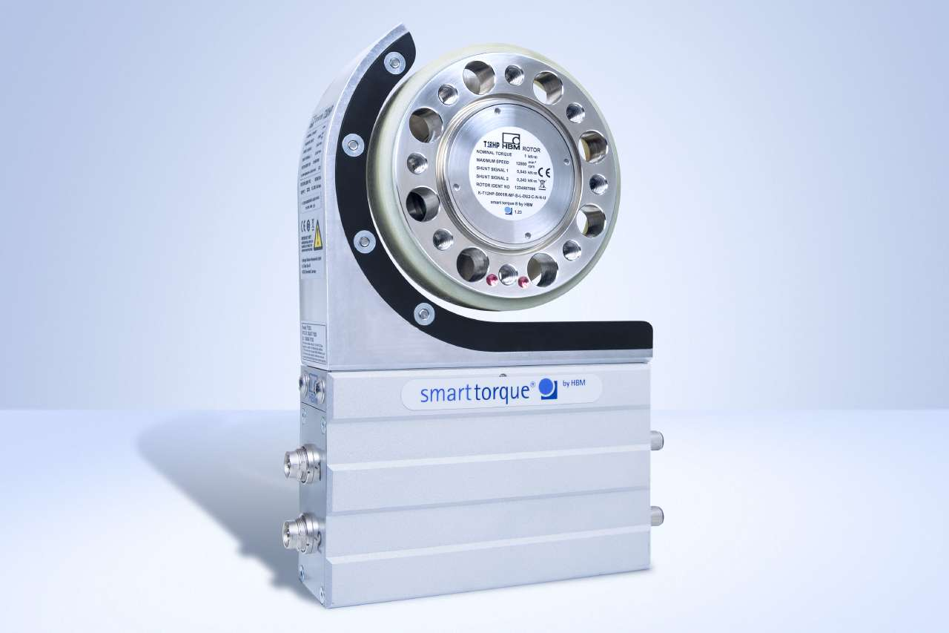
New HBM smarttorque flagship: The T12HP digital torque transducer. Image: HBM

About HBM Test and Measurement
Founded in Germany in 1950, Hottinger Baldwin Messtechnik GmbH (HBM Test and Measurement) is today the technology and market leader in the field of test and measurement. HBM's product range comprises solutions for the entire measurement chain, from virtual to physical testing. The company has production facilities in Germany, USA, China and Portugal and is represented in over 80 countries worldwide.

