High-Speed Optical Tunable Filter with unique features for static and dynamic applications

- Suitable for optical filtering applications (static or dynamic)
- Wide and fine tuning with top resolution and noise to signal ratio
- Stable operation in demanding environments

The unique FS02 - BraggMETER Filter, a long-time proven and reliable component used in HBM FiberSensing’s top class optical interrogators, has now been made available to others. Featuring low voltage excitation and a wide tuning range, it is ideal for most optical filtering applications in test and measurement, telecom, and fiber optic sensing.

The FS02 - BraggMETER is a high-speed Optical Tunable Filter, which integrates proprietary cavity design without guiding optics, resulting in a compact, robust, and vibration-resistant device. The filter is encapsulated in an athermal package, which ensures an excellent thermal stability.

In addition, it offers
- wide free spectral range (FSR≥80nm or ≥100nm) centered at 1550nm;
- excellent signal to noise ratio (side band rejection >20dB);
- high finesse (typical F = 700); and
- enhanced thermal stability (<1nm/ºC).

Suited for many applications
The careful design of the FS02 filter makes it best suited for integration of high-end products and also for research and education purposes in universities and R&D laboratories.
Examples include fiber swept laser sources, optical sensing equipment, optical coherence tomography (OCT) systems, and spectral characterization tools.

More information about the product is available at https://www.hbm.com/en/6656/tunable-optical-filter-fs02-braggmeter/

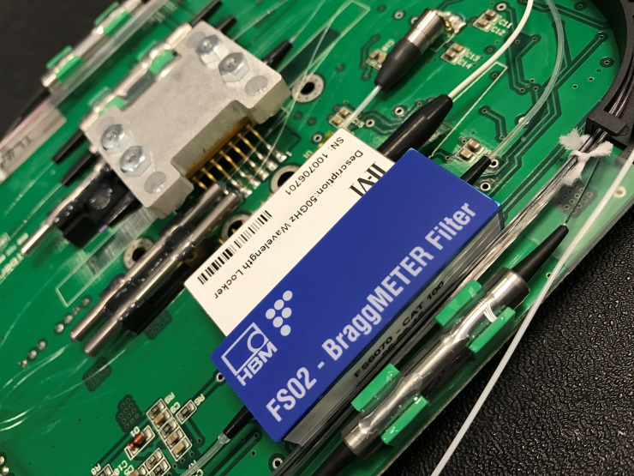
FS02 - BraggMETER Optical Tunable Filter

About HBM FiberSensing
HBM FiberSensing is a European company specialized in the development and production of advanced monitoring systems based on optical Fiber Bragg Grating (FBG) technology. It concentrates all optical business of HBM Test and Measurement and is certified in accordance with ISO 9001:2008 standards.
Founded in Germany in 1950, Hottinger Baldwin Messtechnik (HBM) is today the technology and market leader in the field of test and measurement. The company has production facilities in Germany, USA, Portugal and China and is represented in over 80 countries worldwide.
www.hbm.com/fs

