Data Recorder Provides Custom Structural Health Monitoring Software and App

- HBM introduces a data recorder and data acquisition (DAQ) software that provides extensive structural health monitoring functions
- The system allows for parallel measurements using a single data recorder
- The “HBM Push” app provides automatic notifications about important events that occur on a monitored object

HBM Test and Measurement (HBM) provides the QuantumX data acquisition system and catman software as a comprehensive structural health monitoring package for data acquisition on bridges, tunnels, wind turbines, and other buildings and infrastructures. The package features a function that allows a single data recorder to be used for taking different measurements in parallel, thus adding extra flexibility.

Up to 15 different measurement tasks per data recorder can be performed in parallel and saved fully autonomously at a total sample rate of up to 5 MS/s. The catman software enables the number of channels and sample rates to be individually set for each measurement, and allows the start and end conditions to be separately controlled. Therefore, it is easy to implement complex tasks such as the monitoring of multiple tracks or lanes on a bridge. Furthermore, users have higher flexibility in acquiring data in a more targeted and efficient way.

Integrated FTP server ensures convenient data transfer
In addition, catman generates a separate file for each measurement task, which can be stored locally and automatically uploaded to an FTP server. The software provides a wide range of functions for subsequent analysis such as signal computation, frequency analysis, and intelligent data reduction.

The HBM Push app ensures that you never miss an important event again
The HBM Push app is an integral part of the structural health monitoring package. It notifies the user about specific events occurring on the monitored object – by sending a push message to the user's smart phone, no matter where they are. The catman software allows the user to define these events. The Push ID can also be shared to notify others about the events. Security is guaranteed: All messages are encrypted during transmission. This app is available for free.

catman software in other applications
This and other catman 5.0 functions are well-suited for structural health monitoring as well as for mobile road tests and long-term measurements in test benches and for durability analysis and development tests.

You will find more information about the product at www.hbm.com/de/catman

Click here to download the HBM Push app: https://play.google.com/store/apps/details?id=com.hbm.push

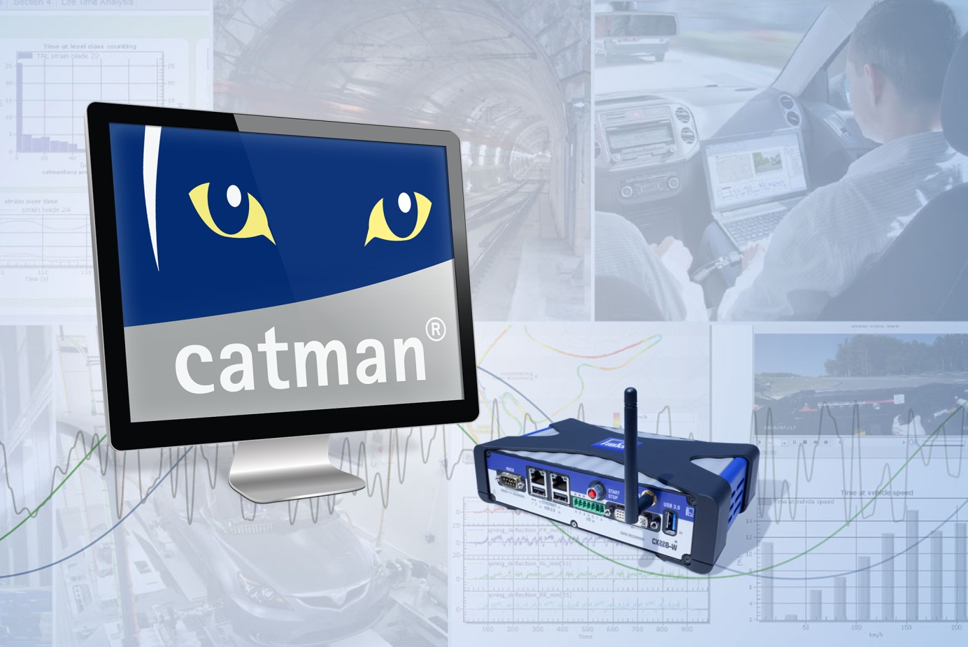

Essential to structural health monitoring: The QuantumX CX22B-W data recorder and catman software

About HBM Test and Measurement
Founded in Germany in 1950, Hottinger Baldwin Messtechnik GmbH (HBM Test and Measurement) is today the technology and market leader in the field of test and measurement. HBM's product range comprises solutions for the entire measurement chain, from virtual to physical testing. The company has production facilities in Germany, USA, China and Portugal and is represented in over 80 countries worldwide.

