New PW15iA Digital Load Cell—The “All-Rounder” for Automated Applications

- New digital load cell that comes in commonly-used standard dimensions
- Integrated weighing function for checkweighing, filling and batching
- Highest possible degree of protection, IP68/IP69K

HBM Test and Measurement (HBM) has launched the new PW15iA digital load cell, a practical multi-functional product for use, for example, in packaging machinery. Due to its commonly-used standard dimensions, the highest possible degree of protection, IP68/69K, and a wide range of digital special functions, the load cell is quickly ready for use, even in existing structures.

The PW15iA digital load cell is mainly used in packaging machinery. Since the load cell comes with many additional functions (e.g. checkweighing, filling, and batching), there is no need to develop them separately for the packaging machinery. This significantly reduces development time for the machine manufacturer.
The PW15iA’s dimensions and bolt spacing correspond to those of the “SP4M footprint” industry standard. This enables the load cell to be quickly integrated into existing systems, without any additional construction effort. The PW15iA is made of stainless steel and has the highest possible degree of protection, IP68/IP69K. Thus, the load cell withstands industrial cleaning and is corrosion-resistant.
The combination of the highest possible degree of protection, compatibility with industry-standard dimensions, and useful weighing functions allows the use of PW15iA load cells in many different applications, well beyond the field of packaging machinery—ranging from automated batching to underwater force measurement.
You will find more information and an article about the testing of high-performance swimwear, using PW15iA at https://www.hbm.com/en/6215/pw15ia-digital-load-cell-for-automated-weighing-application/

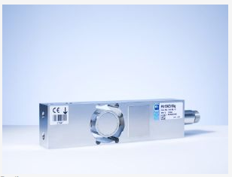
PW15iA Digital Load Cell: The all-rounder for use in packaging machinery and many other weighing technology applications

About HBM Test and Measurement
Founded in Germany in 1950, Hottinger Baldwin Messtechnik GmbH (HBM Test and Measurement) is today the technology and market leader in the field of test and measurement. HBM's product range comprises solutions for the entire measurement chain, from virtual to physical testing. The company has production facilities in Germany, USA, China and Portugal and is represented in over 80 countries worldwide.

