HBM Weighing Terminal wins the Readers’ Choice Award

- HBM Test and Measurement’s new weighing terminal WTX120 awarded the “Best Weighing Instrumentation” 2017
- The terminal was one of the 60 products nominated for the “Weighing Review” magazine’s “Readers’ Choice Awards”
- WTX120 provides plant and machine manufacturers with a superior solution for process weighing, filling and sorting

The readers of “Weighing Review” magazine have chosen HBM Test and Measurement’s new weighing terminal WTX120 as the “Best Weighing Instrumentation” 2017. The recently launched terminal combines the major technical properties of modern weighing electronics with outstanding ease of use and offers standard industrial interfaces such as PROFINET, EtherNet/IP, PROFIBUS and Modbus-TCP.

More than 60 products nominated

In the fourth edition of the “Readers’ Choice Awards”, more than 60 products were nominated and over 1700 votes were cast. WTX120 as “Best Weighing Instrumentation” fulfills all technical and legal needs with its maximum resolution of 30,000d (legal for trade: 10,000e). Furthermore, it can be calibrated directly on site. Buttons and the illuminated screen with plain text menus assure total ease of use. The terminal is complemented with PanelX weighing software supporting start-up and servicing.

Complete weighing solutions by HBM

Moreover, users can benefit from HBM’s many years of experience as a global market leader. The company offers the complete measuring chain, from load cells to electronics and interfaces.

More information: www.hbm.com/wtx

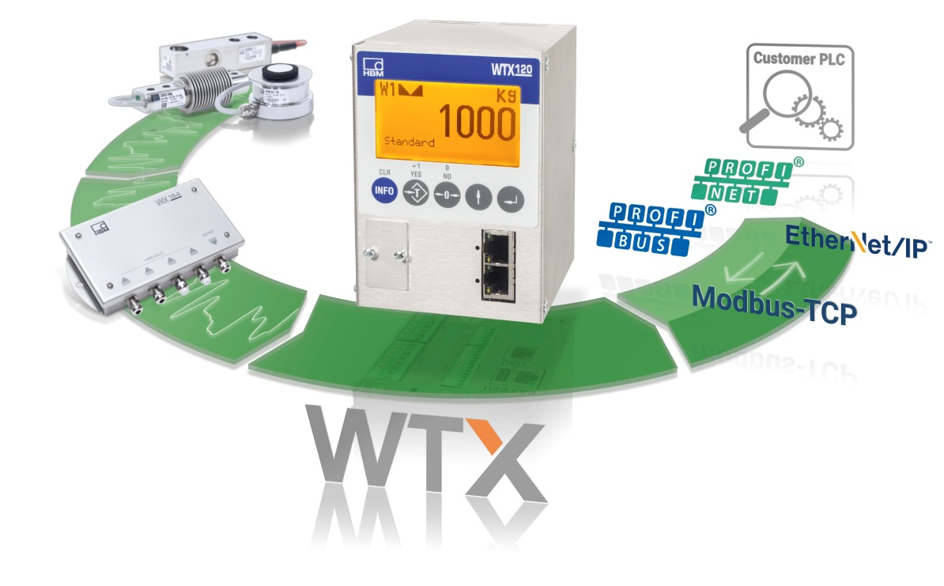
HBM’s WTX120 weighing terminal has won the Weighing Review magazine’s Readers’ Choice Award as Best Weighing Instrumentation 2017.

