Critical Data on Engineering Structures Instantly Available via Cloud

- HBM presents a complete package for structural health monitoring of engineering structures
- Complete package – Concept – Installation – Operation – Cloud-based data access
- Important parameters for assessment of engineering structures instantly available

The new, cloud-based structural health monitoring (SHM) package provided by test and measurement expert, HBM Test and Measurement (HBM), ensures access to data relevant to the structural health of transport infrastructures—such as bridges or tunnels—at any time. Customers benefit from a pre-installed, complete structural health monitoring package which includes the provision of data via the Internet.

Structural health monitoring (SHM) involves the long-term observation of engineering structures such as bridges or tunnels over their entire lifetime. Characteristic values enable test engineers to gain better insights into the structural health and progression of damage in engineering structures. Operators can take appropriate corrective measures in case of safety-related events or exceptional stresses.

Complete installation of the systems by HBM
The structural health monitoring package benefits from HBM’s many years of application know-how in test and measurement; it allows users to freely select, for instance, the technology (e.g., strain-gauge or fiber-Bragg-grating based) that best fits the respective measurement task. Since there are various billing models (e.g. monthly fee) for using the structural health monitoring solution, users do not necessarily have to invest in test and measuring equipment or acquire test and measurement knowledge.

Access to characteristic values relevant to the assessment of engineering structures
The solution from HBM enables parameters that are typical for an engineering structure to be retrieved through web-based reports. Depending on the project and the customer’s wishes, the “HBM Cloud” provides access to parameters that are relevant to the assessment of an engineering structure, such as natural frequency, damping ratio, traffic load, axle load as well as static parameters such as tilting, change in bending, mechanical stress, or exceeding of limit values.

With the Cloud solution, users do not have to set up their own server for data storage and analysis. The Microsoft Azure platform ensures that the most stringent standards for data security are met, including those under German law.

Click here for the latest HBM Cloud demo: http://demo.hbmcloud.com
For more information please go to https://www.hbm.com/en/5530/structural-health-monitoring/
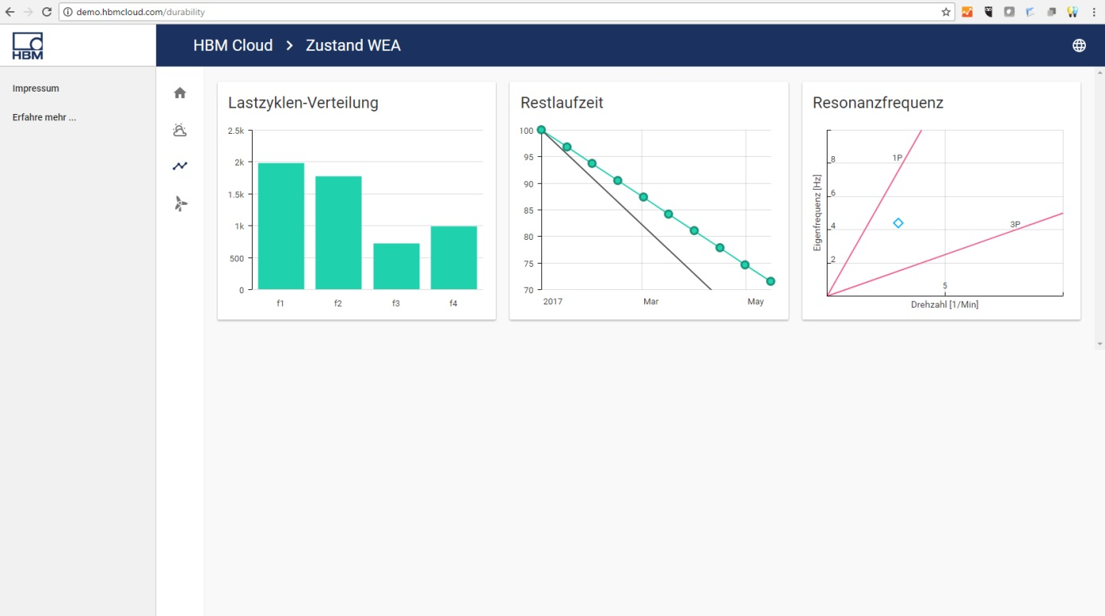
Image: Screenshot of the HBM Cloud during the transmission of live status data of a weather station and a wind power model installation.

About HBM Test and Measurement
Founded in Germany in 1950, Hottinger Baldwin Messtechnik GmbH (HBM Test and Measurement) is today the technology and market leader in the field of test and measurement. HBM's product range comprises solutions for the entire measurement chain, from virtual to physical testing. The company has production facilities in Germany, USA, China, and Portugal and is represented in over 80 countries worldwide.

