U15 High-Precision Force Transducer with Enhanced Specifications

- For high-precision measurements in testing machines or test benches
- Now available with capacities of up to 2.5 meganewtons; guaranteed accuracy class starting from 10% of the nominal (rated) measuring range
- Ideal for combination with the QuantumX MX238B measuring amplifier, to implement a cost-effective high-precision measuring chain

The U15 reference force transducer from HBM Test and Measurement (HBM) is now also available with a nominal (rated) measuring range of up to 2.5 meganewtons. Another novelty is its guaranteed accuracy class of 0.5% starting from 10% of the nominal (rated) measuring range (up to now 20%). This extends the sensor’s range of possible applications in calibration and high-precision testing tasks.

HBM has technically improved and enhanced the U15 force transducer to strengthen its position as a particularly cost-effective and highly precise solution for many testing tasks.

Moreover, users who combine the U15 force transducer with HBM’s newly launched precise QuantumX MX238B measuring amplifier can implement a high-precision measuring chain at an attractive price. In addition, the QuantumX amplifier series’ modular design opens up an extended range of applications for the simultaneous acquisition of other measured quantities and for alternative sensor technologies.

You will find more information about the U15 high-precision force transducer at: https://www.hbm.com/de/2926/u15-kraftaufnehmer-fuer-kalibrieraufgaben/

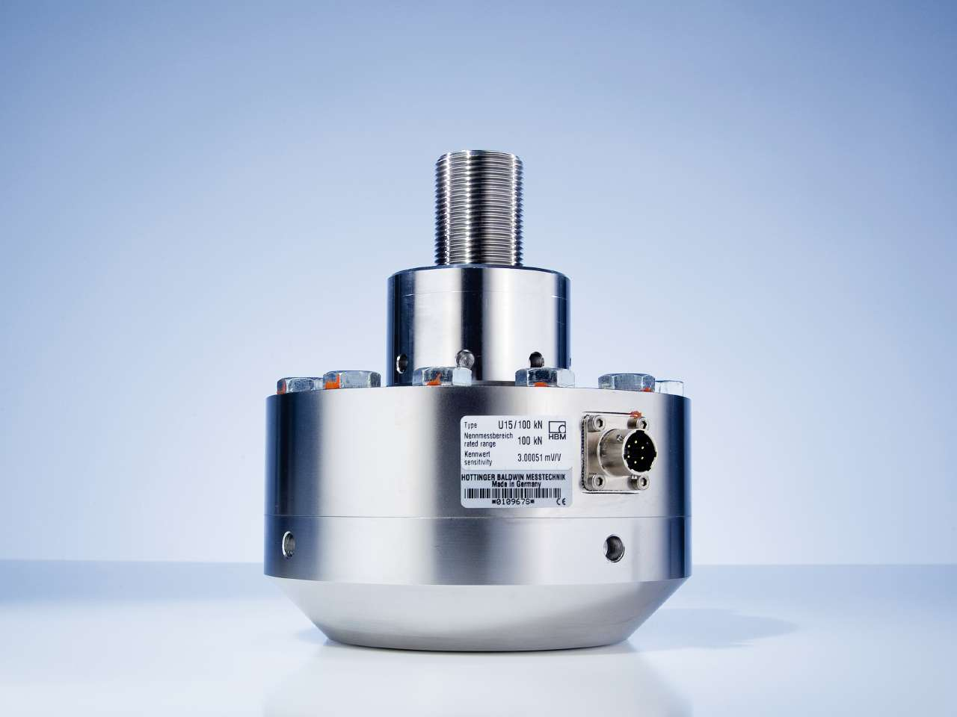

Image: U15 high-precision force transducer from HBM

About HBM Test and Measurement
Founded in Germany in 1950, Hottinger Baldwin Messtechnik GmbH (HBM Test and Measurement) is today the technology and market leader in the field of test and measurement. HBM's product range comprises solutions for the entire measurement chain, from virtual to physical testing. The company has production facilities in Germany, USA, China, and Portugal and is represented in over 80 countries worldwide.

