New! Higher data acquisition rate and time synchronization in FS22DI optical interrogators
- Maximum sampling rate up to 1000S/s
- NTP clock synchronization now possible*
- Increased operating temperature ranges from [10º C to 40º C] to [0º C to 50º C]
- Improved resolution and stability
- Slightly improved consumption

* (connection to an NTP server running on the control PC required)

HBM FiberSensing has launched a new version of its high-resolution FS22 Industrial BraggMETER DI interrogator for dynamic acquisition rates with improved data acquisition rate.

- Offers real sampling rates of operation from 50 S/s, 100 S/s, 200 S/s, and 500 S/s, to 1000 S/s.
- Improved time synchronization with the integration of the NTP protocol in the interrogator internal processing unit.
- One of the very few interrogators in the market covering at least 100 nm wavelength range and acquisition rates of 1000 S/s.

Additional Features
  - Up to 8 optical channels with simultaneous and parallel acquisition of all sensors connected to all optical channels without reduction of selected acquisition rate and resolution.
  - High dynamic range meeting demanding sensing networks with long distances and losses.
  - Integration in hybrid measurement solutions: Compatibility with catman® software enables combination with classical HBM devices into one system requiring a single interface. Additional results granted by selecting the best suited technology for each parameter.
  - Continuous swept laser scanning technology with proven reliability.

Widened Applicability of the FS22 DI interrogator
- New and enhanced features increase its applicability in testing and monitoring projects for Civil Engineering, Geotechnics, Aeronautics and Aerospace markets.
- New doors opened in applications for Railways, Automotive and Wind industries requiring higher acquisition rates.

Compatible with BraggMONITOR DI and catman® Software
- FS22 Industrial BraggMETER DI with 1000 S/s acquisition rate delivered with free BraggMONITOR DI software.
- 1000 S/s acquisition rate compatible with BraggMONITOR DI version 1.6 or higher.
- Catman® software available for further possibilities in acquisition, data processing, recordings, data storage, visualization and integration with other equipment.
- 1000 S/s acquisition rate is compatible with catman Easy or catman AP version 5.0 and above using the Easy Optics Module.

For more information please go to https://www.hbm.com/en/4604/fs22-industrial-braggmeter-optical-interrogator/

Image: FS22 Industrial BraggMETER DI interrogator
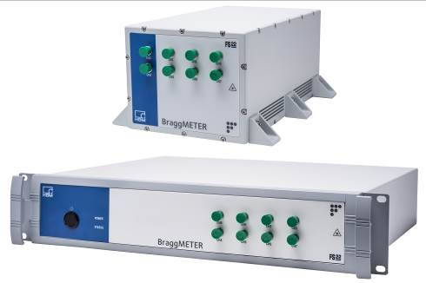

About HBM FiberSensing
HBM FiberSensing, S.A. is a European company specialized in the development and production of advanced monitoring systems based on optical Fiber Bragg Grating (FBG) technology. It concentrates all optical business of HBM Test and Measurement and is certified in accordance with ISO 9001:2008 standards.
Founded in Germany in 1950, Hottinger Baldwin Messtechnik (HBM) is today the technology and market leader in the field of test and measurement. The company has production facilities in Germany, USA, Portugal and China and is represented in over 80 countries worldwide.
www.hbm.com/fs

