T40HS High-Speed Torque Transducer with New Measuring Ranges

- The high-speed torque transducer T40HS now offers smaller measuring ranges starting at 100 Nm; and rotational speeds up to 45,000 rpm.
- Due to its short design and high stiffness, T40HS provides a very high accuracy class of 0,05.
- It is ideal for testing propulsion systems, turbines, transmission test rigs, adjustable actuators or the efficiency of complete drive trains.
The lightweight torque transducer T40HS from HBM Test and Measurement (HBM) is now available with a nominal (rated) measuring range starting at only 100 Nm at a guaranteed accuracy class of 0.05, whilst facilitating rotational speeds up to 45,000 rpm.

T40HS is characterized by its short construction, its high stiffness and its precision, and thus allows for a very low measurement uncertainty. The lower measuring range of T40HS is especially beneficial while testing high-speed energy recovery systems, electrical drives, propulsion systems, turbines, transmission test rigs, adjustable actuators, or the efficiency of complete drive trains.

Due to its lightweight titanium body, the new high-speed torque sensor series T40HS also features a low moment of inertia. The T40HS has been designed in accordance with the relevant European standards and also complies with US and Canadian standards. The product has been certified with the FCC, IC, and CE labels.

HBM is the world's leading supplier of precision torque measurement technology. The torque measuring flanges T40B and T12HP are used worldwide in test stands with the highest accuracy requirements. In addition, the portfolio of customer-specific and special sensors, e.g. for high torques or very high speeds.

Further information at https://www.hbm.com/en/5673/t40hs-high-speed-torque-transducer/
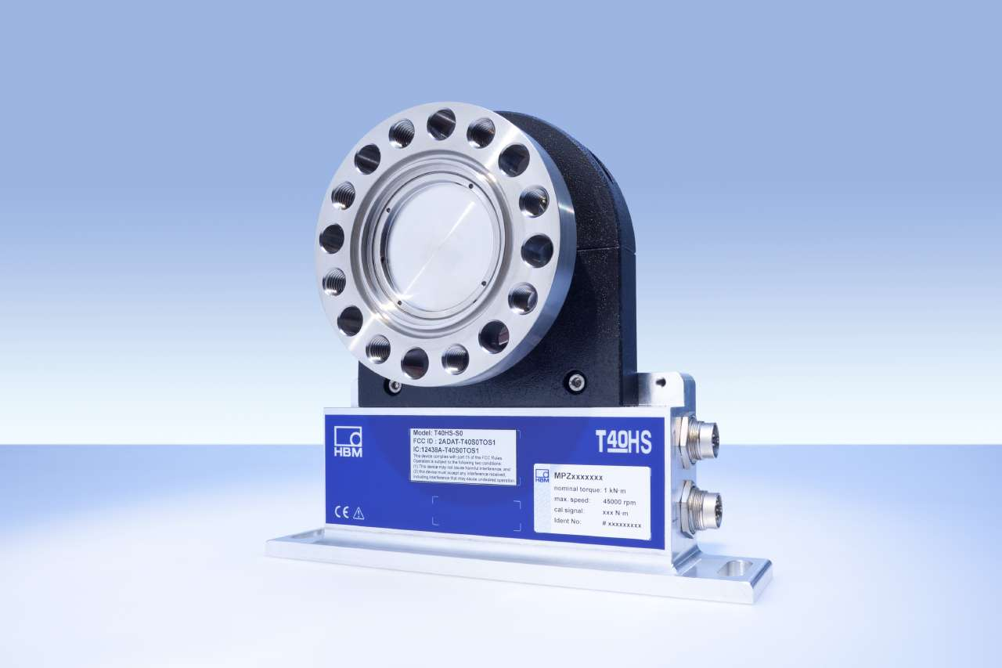

Image: T40HS High-Speed Torque Sensor

About HBM Test and Measurement
Founded in Germany in 1950, Hottinger Baldwin Messtechnik GmbH (HBM Test and Measurement) is today the technology and market leader in the field of test and measurement. HBM's product range comprises solutions for the entire measurement chain, from virtual to physical testing. The company has production facilities in Germany, USA, China, and Portugal and is represented in over 80 countries worldwide.

