Complete Solutions in Weighing Technology: HBM Expands Its WTX Series with the New Ultra-Robust WTX110-A Weighing Terminal

- Ideally suitable for utilization in harsh environments and compliant with the stringent hygiene requirements of the food, chemical, or pharmaceutical industries
- Convenient soft-key control through a high-resolution, 4.3-inch TFT color display
- Ethernet TCP/IP ensures easy and secure remote access

HBM Test and Measurement has expanded its high-class WTX series with a new version for use with analog load cells - the new, legal-for-trade WTX110-A weighing terminal. The robust WTX110-A weighing terminal combines the key technical and legal features of cutting-edge and future-proof weighing electronics. All the housing versions offer the IP69K degree of protection and thus can be put to use in the harsh environments prevalent in the chemical or pharmaceutical industries. They comply with the stringent requirements for hygiene measures of the food industry.

The WTX110-A stands out for its tremendous user-friendliness. Its use on-site is significantly easier than conventional weight indicators due to its high-class, 4.3-inch color display and convenient soft-key control.

Well prepared for the future
The WTX110-A has one particularly outstanding feature – it facilitates extremely easy configuration or calibration as well as other servicing measures. These can be carried out quickly and conveniently on site or in a distributed system using HBM’s PanelX weighing software. This enables, for instance, a remote calibration to be performed via the Internet quickly and cost-effectively. An encrypted connection ensures secure data exchange through (remote) access via both PanelX software and the WTX Mobile App. HBM is one of the first manufacturers of weighing technology products that offer this highly innovative option for future applications in the Industrial Internet of Things.

More than just components – complete weighing solutions from HBM
The WTX110-A terminal is an all-rounder, which is ideally suitable for being combined with load cells from HBM’s range of products, thus, offering complete weighing solutions from a single source. Users have been benefiting from the many years of experience HBM has as the global market leader. HBM provides a complete and highly precise measurement chain, ranging from the load cell, through the electronics, to a secure remote access and service, all at a fair price.

Further information about the product can be found at www.hbm.com/wtx

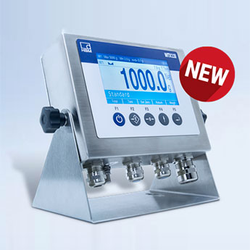
The new WTX110-A weighing terminal.
About HBM Test and Measurement
Founded in Germany in 1950, Hottinger Baldwin Messtechnik GmbH (HBM Test and Measurement) is today the technology and market leader in the field of test and measurement. HBM's product range comprises solutions for the entire measurement chain, from virtual to physical testing. The company has production facilities in Germany, USA, China, and Portugal and is represented in over 80 countries worldwide.

