The Cost-Effective All-Rounder for Many Nominal (Rated) Torque Values

- T22 torque transducer for nominal (rated) torque from 0.5 Nm to 1 kNm
- Particularly cost-effective model
- Wide range of applications

The T22 torque transducer from HBM Test and Measurement (HBM) has been available for nominal (rated) torque values of up to 1 kNm, and now also covers small nominal (rated) torque values of 0.5 Nm, 1 Nm, and 2 Nm. It guarantees maximum flexibility in applications in the laboratory and in end-of-line test benches as well as in applications that require smaller nominal (rated) torque such as tests in medical engineering, bearing test benches, and material and haptic tests.

Save time and money
The T22 is a particularly cost-effective torque transducer that, since it comes with integrated electronics, requires no additional amplifier to be used and is maintenance free. Users benefit from minimal time and cost expenditure and integration effort. Due to its compact design, the torque transducer is ideally suited for dynamic and static torque measurement on rotating and non-rotating components.

Further information about the product can be found here: https://www.hbm.com/de/2384/t22-drehmoment-messwelle/

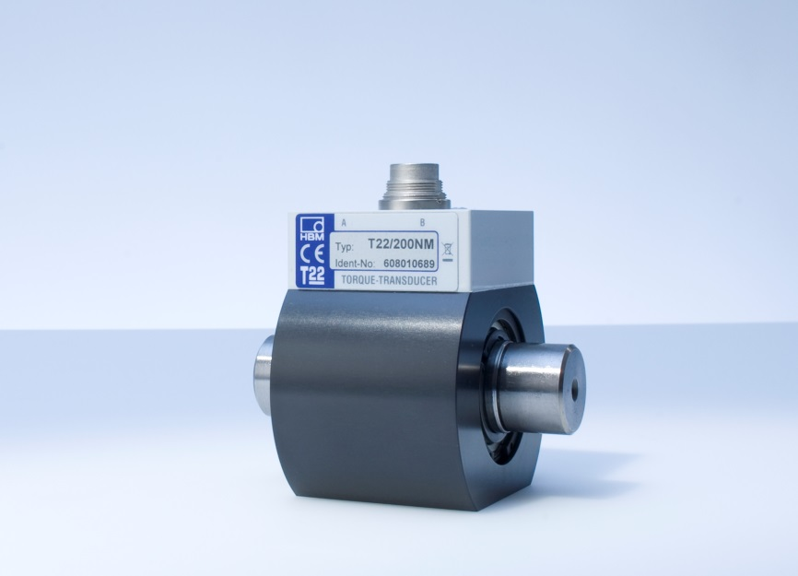
T22 torque transducer for nominal (rated) torque values from 0.5 Nm to 1 kNm
Caption: HBM

About HBM Test and Measurement
Founded in Germany in 1950, Hottinger Baldwin Messtechnik GmbH (HBM Test and Measurement) is today the technology and market leader in the field of test and measurement. HBM's product range comprises solutions for the entire measurement chain, from virtual to physical testing. The company has production facilities in Germany, USA, China and Portugal and is represented in over 80 countries worldwide.

