New Online Guide on Strain Measurement

- New online guide, focusing on the selection, installation, data acquisition, and analysis of electrical as well as optical strain gauges.
- Expert answers to all to relevant questions about strain measurement
- More than 100 articles available online

HBM has launched a new Strain Measurement online guide, focusing on the selection, installation, data acquisition, and analysis of electrical as well as optical strain gauges. The new portal contains comprehensive information about measuring strain, including valuable tips from leading strain measurement experts.

When it comes to strain measurement, businesses and asset owners may feel intimidated due to the lack of information or, on the other hand, information overload. And often, in the absence of proper guidance from experienced professionals, they will give up the attempts to learn this topic and probably jeopardize cost-effective decisions when it comes to choosing the right measuring instrument.

Experts from HBM, test and measurement specialists, have dug deep to provide their best answers to relevant questions about strain measurement, either performed with strain gauges or with fiber optical strain sensors. Based on their knowledge, an ultimate step-by-step online guide has now been launched, with updated and unparalleled content about optical and electrical strain measurements, gauges, and sensors.

By navigating through the brand-new strain-related HBM webpages, readers may learn the “what”, “how” and “why” of strain measurement and related-technologies, including the definition of strain, tips for selecting and installing gauges and sensors, guidelines to acquire data, types of applications, among many others.

The journey starts at the strain measurements basics page at https://www.hbm.com/en/6896/strain-measurement-basics/ : From there, users can choose to explore the world of strain gauges or the innovative field of optical fiber sensing.

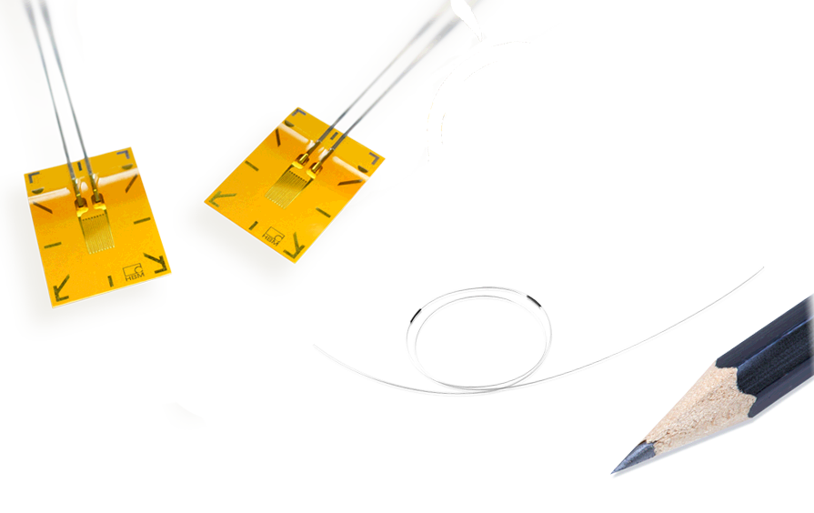

HBM’s new strain measurement online guide is focusing on the selection, installation, data acquisition, and analysis of electrical as well as optical strain gauges.
About HBM Test and Measurement
Founded in Germany in 1950, Hottinger Baldwin Messtechnik GmbH (HBM Test and Measurement) is today the technology and market leader in the field of test and measurement. HBM's product range comprises solutions for the entire measurement chain, from virtual to physical testing. The company has production facilities in Germany, USA, China, and Portugal and is represented in over 80 countries worldwide.

