New PACEline CSW Miniature Force Washer Allows Reliable Shear-Force Monitoring
- New piezoelectric miniature force washer facilitates reliable force measurement, even in confined spaces and/or unfavorable environments (EMC, humidity)
- Broad measuring range enables different measurement tasks to be conducted with one sensor
- Fast installation is possible due to matching accessories

HBM, the test and measurement expert, has introduced its new PACEline CSW miniature force washers for reliable shear-force monitoring. The new piezoelectric sensors’ typical fields of application include force monitoring tasks in machining processes such as cutting, milling, and turning. Additionally, the CLP miniature sensors enable a swift upgrade of the force washer to a sensor with multiple axes.

The PACEline CSW piezoelectric shear-force washers have a very low height, ranging between 3 and 5 mm. Once the sensors are mounted and calibrated, they can measure shear force in the direction of the cable reliably. The CSW force washers take up extremely little space due to their low height and they have the same dimensions as the type PACEline CLP force washers (for normal force measurement) from HBM and proven useful for many years.

Combining them with the CLP force washers and using at least two CSW force washers mounted in different directions enables measurement systems to be set up to measure force in different directions simultaneously and, at the same time, take up only very little space.

The PACEline CSW series force washers have a fixed cable; they are made from stainless steel materials, and comply with the IP65 degree of protection. The PACEline CSW is available with maximum capacities ranging from 1 kN to 8 kN. Installation takes little time owing to matching accessories that are also available directly from HBM. Due to galvanic isolation, no additional insulation washers are required.

HBM markets its series of products for piezoelectric force measurement under the trade name “PACEline”. PACEline sensors and charge amplifiers complete the wide range of force sensors based on strain-gauge technology. Hence, customers can choose between the sensor technologies that best fit their applications, at any time.

Complete product information at https://www.hbm.com/en/7363/paceline-csw-piezo-miniature-load-washers-for-shear-forces/

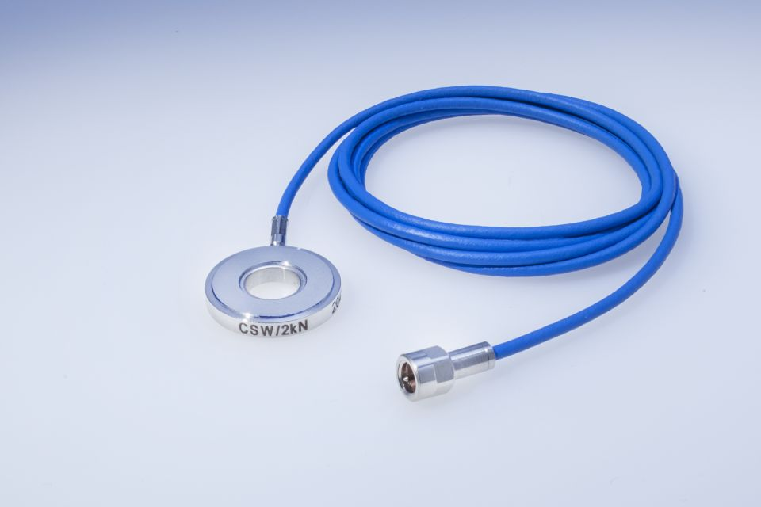
HBM’s new PACEline CSW piezoelectric force washer

About HBM Test and Measurement
Founded in Germany in 1950, Hottinger Baldwin Messtechnik GmbH (HBM Test and Measurement) is today the technology and market leader in the field of test and measurement. HBM's product range comprises solutions for the entire measurement chain, from virtual to physical testing. The company has production facilities in Germany, USA, China, and Portugal and is represented in over 80 countries worldwide.

