New T21WN “All-Inclusive” Torque Transducer Allows Simultaneous Measurement of Torque, Rotational Speed, and Angle of Rotation

- HBM’s new, cost-effective T21WN torque transducer
- Ideal for measuring low torque as well as rotational speed and/or angle of rotation
- Predecessor of the successful T20WN model—provides a more extensive range of functions at the same price

HBM Test and Measurement (HBM) has introduced its new T21WN torque transducer. Based on strain-gauge technology, the T21WN uses contactless energy and measurement signal transmission to measure torque. The torque transducer enables demanding static and dynamic measurements of torque, rotational speed, and angle of rotation to be performed on non-rotating as well as rotating components. It is ideal for laboratory, test shop, and testing applications as well as for use in production and process monitoring and quality assurance.

Apart from the torque output signal of +/-10 V at nominal (rated) torque, it also provides a standard frequency output signal of 10 kHz+/- 5 kHz.

The T21WN torque transducer is available with nominal (rated) torques ranging between 0.1 N·m and 200 N·m. The maximum permissible rotational speed of torque measuring system is up to 20,000 rpm, depending on the measurement range. An integrated rotational speed/angle of rotation measuring system with 360 pulses per revolution completes the transducer and can be used up to the specified maximum nominal (rated) rotational speed without restrictions.
The transducer is supplied with the direct voltage of 24 V that is common in test benches. The T21WN is suitable for use in substantially more dynamic applications than the preceding model, the T20WN, thanks to its measurement bandwidth of 1 kHz. Users benefit from a significantly broader range of functions than with the preceding model – at the same price.
More information about the T21WN torque transducer can be found at https://www.hbm.com/en/7343/t21wn-torque-meter-with-cylindrical-shaft-stubs/
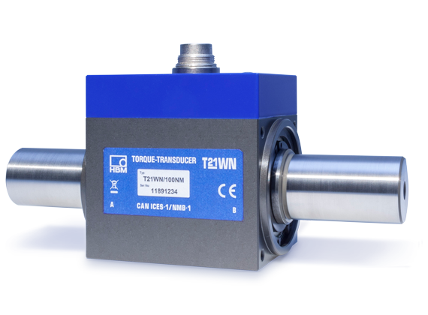
HBM’s new T21WN torque transducer

About HBM Test and Measurement
Founded in Germany in 1950, Hottinger Baldwin Messtechnik GmbH (HBM Test and Measurement) is today the technology and market leader in the field of test and measurement. HBM's product range comprises solutions for the entire measurement chain, from virtual to physical testing. The company has production facilities in Germany, USA, China, and Portugal and is represented in over 80 countries worldwide.

