ClipX One-Channel Signal Conditioner Facilitates Integration into Machines and Production Systems

- Universal inputs such as force, strain, torque, pressure, displacement, temperature, current, and voltage
- High accuracy class of 0.01, with 24-bit resolution and 3.5 kHz measurement bandwidth
- High flexibility thanks to open standard interfaces

HBM Test and Measurement (HBM) is introducing its new industrial signal conditioner ClipX – "Clip. Measure. Control." With an accuracy class of 0.01 and included digital working standard calibration certificate, ClipX is setting new standards in industrial process control. The module adapts to any measurement task, regardless of whether it is used with single- or multiple-channel applications, manufacturing machines, or production monitoring.

ClipX allows for easy implementation of any number of individual, stand-alone measurement chains or measurement systems with up to 6 devices that can communicate with each other. The signal conditioner provides all the latest automation interfaces to integrate the device into comprehensive, digital control concepts (PROFINET, PROFIBUS, Ethernet/IP™, EtherCAT®, current, and voltage).
Both analog and digital measurement chains can be built up with ClipX. HBM’s sensors are optimally matched to the ClipX signal conditioner and provide interference-proof measurement results.
ClipX already fulfills the requirements of the future networked production. A particular feature is the intuitive web interface that also allows remote operation, parameterization, and diagnosis. ClipX is self-monitoring and helps prevent machine downtime due to the early detection of faults (predictive maintenance). This is possible due to Smart Functions such as health monitoring, remote diagnosis, and pre-calculated channels.
HBM, in addition to its range of signal conditioners and data acquisition systems, also offers sensors for measuring torque, force, displacement and other mechanical quantities. Customers benefit from a complete solution for industrial measurement and control with fast set-up times, high measurement data quality and meaningful results across the entire measurement chain.
Read more about ClipX, the new-generation signal conditioner from HBM at https://www.hbm.com/en/7077/clipx-precise-industrial-signal-conditioner/
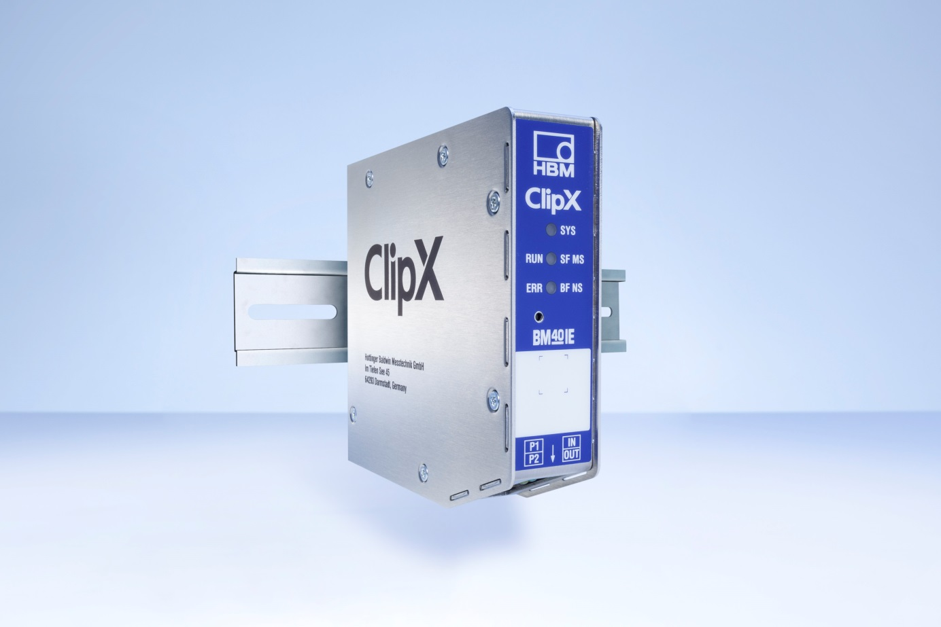
The precise and easily integrable ClipX signal conditioner is the all-rounder for use in measurement and monitoring tasks in test benches, machinery, and production systems. (Image: HBM)
About HBM Test and Measurement
Founded in Germany in 1950, Hottinger Baldwin Messtechnik GmbH (HBM Test and Measurement) is today the technology and market leader in the field of test and measurement. HBM's product range comprises solutions for the entire measurement chain, from virtual to physical testing. The company has production facilities in Germany, USA, China, and Portugal and is represented in over 80 countries worldwide.

