New Measuring Module GEN2tb Enables Convenient and Flexible Entry into Data Acquisition with Ultra-High Sampling Rates
- New GEN2tB portable data recorder from the HBM Genesis HighSpeed series;
- An ideal entry-level product that can be used flexibly for various applications such as eGrid; and e-drive testing, high-speed mechanical testing, and electrical transient recording;
- Usable as a PC front-end or stand-alone device with the integrated hard disk; and
- Includes high-speed data acquisition software—Perception.
With the portable data acquisition system GEN2tB, HBM Test and Measurement (HBM) introduces a high-performance starter device for high-speed measurement technology with sampling rates of up to 250 MS / s. Thanks to its flexible design and the possibility of individual assembly with different data acquisition cards, GEN2tB offers attractive functions for professional users as well. Typical applications include the testing of electrical networks (eGrids), electric drive trains (eDrive), as well as ultra-fast mechanical testing and electrical transient detection.
Thanks to its modular design, the GEN2tB measurement data acquisition system is suitable as an entry-level model, but can also be used as a high-end transient recorder - or even in "mixed" applications. The device has two2 slots, making it a cost-efficient choice for small channel counts.
Compact and stationary use
Owing to itsWith a very compact size, GEN2tB is also suitable can also be used for mobile use in addition to stationary use. The entire GEN2tB system can also be expanded to accommodate up to 12 current or voltage channels, 16 high-speed sensor channels (ege.g., strain gauges or accelerometers up to 500 kS / s per channel), or up to 24 channels of fiber optic digitizers. Again, mixed test setups are possible.
High-speed metrology software Perception included in the price
The price of the GEN2tB data acquisition system includes the high-speed Perception software. This software enables the secure streaming of very large amounts of data at a speed of up to 200 MB / s on the hard disk. Perception can be installed on any number of PCs to control the data acquisition system or ato analyze the data obtained.
Genesis HighSpeed is the modular platform for fast measurements of electrical and mechanical parameters. Thanks to its modular architecture, it is equipped for any high speedhigh-speed measurement task. Build your own configuration consisting of a mainframe, data acquisition card, and Perception software. HBM Genesis HighSpeed products were previously sold under the Nicolet brand. The Nicolet brand is owned by Thermo Fisher Scientific Inc. Corporation.
Read more about the high-speed data recorder GEN2tB at https://www.hbm.com/en/7473/gen2tb-portable-and-powerful-data-acquisition-system/

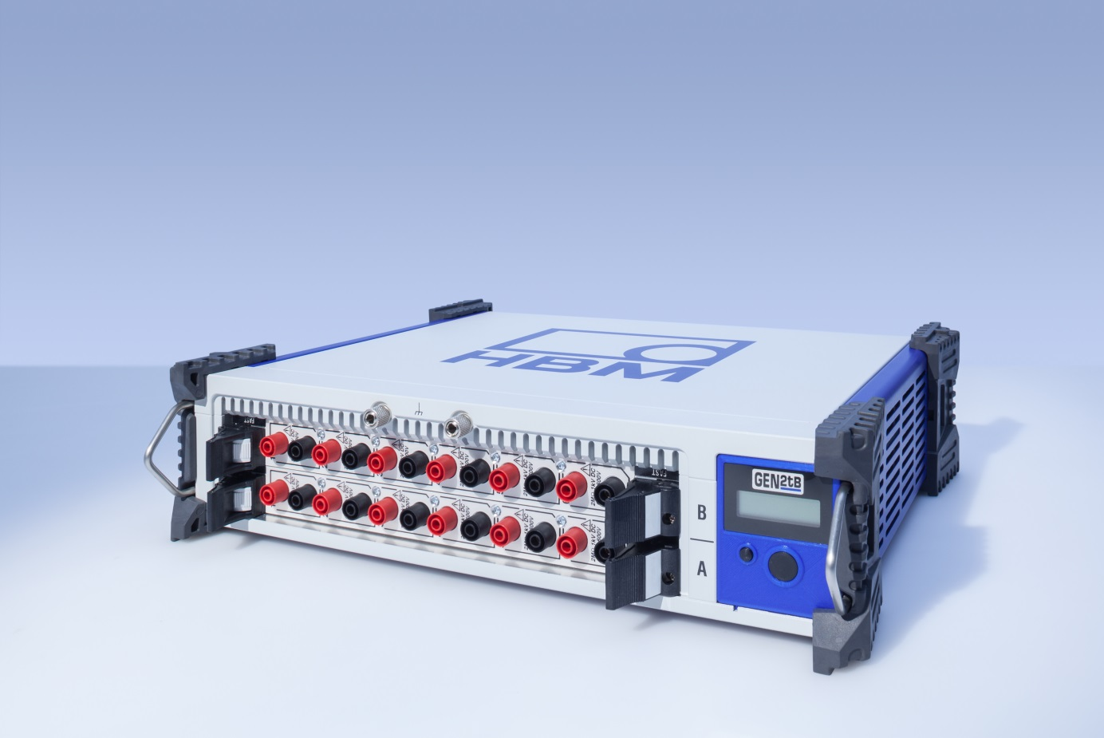
The GEN2tB data acquisition system is perfect for portable use, with low channel counts or applications that require a distributed setup, and comes with free Perception software
About HBM Test and Measurement
Founded in Germany in 1950, Hottinger Baldwin Messtechnik GmbH (HBM Test and Measurement) is today the technology and market leader in the field of test and measurement. HBM's product range comprises solutions for the entire measurement chain, from virtual to physical testing. The company has production facilities in Germany, USA, China, and Portugal and is represented in over 80 countries worldwide.

