Special Strain Gauges for Temperatures up to 350 °C

- HBM expands its range of strain gauges with the KFU series for temperatures up to 350 °C.
- It is ideal, for instance, to measure strain in autoclaves or environments with steam.
- It is shipped along with a 1 m long cable.

HBM Test and Measurement (HBM) expands its range of strain gauges with the KFU series, which can be used at extremely high temperatures up to +350 °C.
The KFU strain gauges are shipped with 1 m long cables and are protected against high temperatures. They are available in grid lengths of 2 mm and 5 mm as well as in different versions, such as linear, T (with two measuring grids) or R (with three measuring grids) rosettes, depending on the application’s requirements. Additionally, the KFU strain gauges are available with temperature responses matched to steel, austenitic steel, and aluminum.
For strain measurements in autoclaves or environments with steam
Typical applications include strain measurements in autoclaves or environments with steam. The strain gauges can be used at high temperatures for specified durations; at 350 °C they can be used for 72 hours or at 300 °C for 360 hours.
Go-ahead for cooperation with Kyowa Electronic Instruments
The series KFU strain gauges are the first products manufactured by HBM in collaboration with the Japanese manufacturer Kyowa Electronic Instruments, and HBM has added this series to its standard range of products. This cooperation of two technology leaders enabled HBM to complement its range of products with additional, fascinating sensors, such as those for very high temperatures, and offer these to clients in future.
You will find more information on KFU at https://www.hbm.com/de/7481/kfu-hochtemperatur-dehnungsmessstreifen-bis-zu-350c/

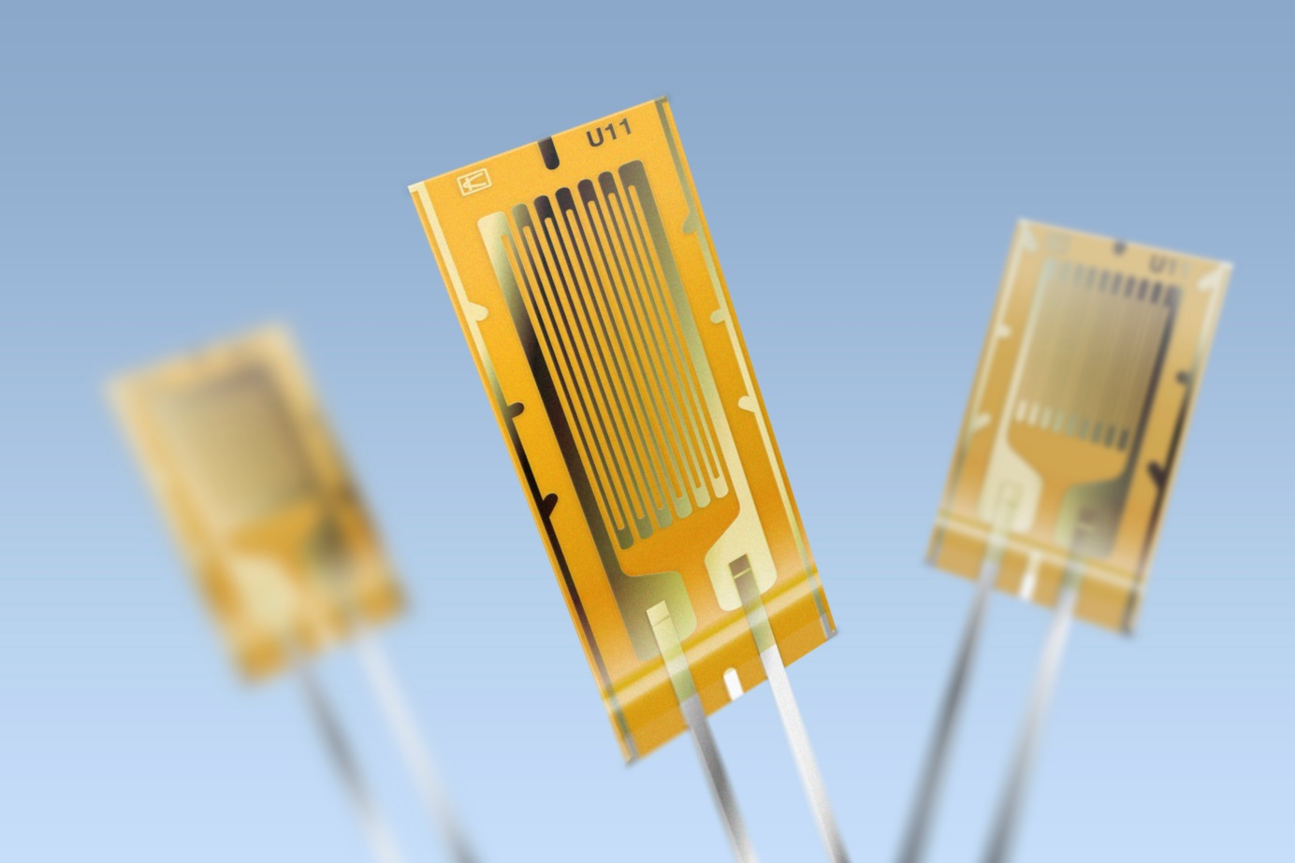
High-Temperature Strain Gauges KFU

About HBM Test and Measurement
Founded in Germany in 1950, Hottinger Baldwin Messtechnik GmbH (HBM Test and Measurement) is today the technology and market leader in the field of test and measurement. HBM's product range comprises solutions for the entire measurement chain, from virtual to physical testing. The company has production facilities in Germany, USA, China, and Portugal and is represented in over 80 countries worldwide.

