Real-Time Test Bench Automation and Data Analysis with the New Profinet Gateway CX27C

- Test and integrate up to 199 sensors in real-time to PROFINET
- Setup real-time cycle times in the millisecond range
- Analyse input data with up to 100 kS/s per channel in parallel via ETHERNET

The QuantumX CX27C gateway module, the latest addition to the QuantumX modular data acquisition system, offers test engineers maximum flexibility in testing their applications and simultaneous integration of up to 199 sensors in PROFINET IRT in real time. QuantumX CX27C is the ideal choice for quick results even in highly automated test benches with small to high channel counts, such as component, powertrain or durability test benches.

In combination with HBM's catman PC software, sensor and signal data can be viewed, analyzed and recorded with sample rates up to 100 kS / s per channel, without affecting real-time automation tasks. The gateway modules perfectly play with the QuantumX and the ultra-rugged SomatXR family, even in a distributable way.

Integration is quick and easy by using automatic sensor recognition (TEDS), auto mapping function or parameter file generation and some diagnosis services.

The QuantumX CX27B gateway module for EtherCAT applications is also available from HBM.

HBM's QuantumX data acquisition system is the perfect tool for almost all test and measurement requirements. QuantumX is the first choice among test engineers worldwide for reliable data acquisition of various physical quantities and sensor technologies. It has the unique ability to acquire information from almost any type of signal or sensor.

Further information about QuantumX CX27C can be found at: https://www.hbm.com/en/2131/quantumx-cx27/

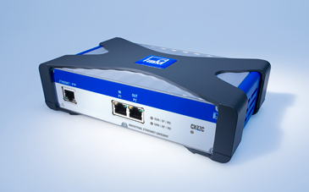
The QuantumX CX27C gateway module allows simultaneous integration of up to 199 sensors in PROFINET IRT in real time.
About HBM Test and Measurement
HBM is the worldwide technology and market leader in the field of test and measurement, weighing technology. HBM’s product range comprises solutions for the entire measurement chain, from sensors through electronics to analysis and simulation software as well as associated services. The company has production facilities in Germany, USA, China and Portugal and is represented in over 80 countries worldwide. HBM currently employs a total of 1,800 staff.

