Measuring large compressive forces economically: New C6B force transducer from HBM

- For maximum capacities from 200 kN to 10 MN
- Degree of protection IP68
- Flexible and economical

With the new C6B force transducer, HBM offers a flexible solution for economical acquisition of large compressive forces. The sensor is cost-effective and specially designed for rugged and dynamic applications.

The C6B force transducer acquires nominal (rated) forces from 200 kN to 10 MN with an HBM accuracy class of 0.5. Typical applications include the construction industry, heavy industry and metalworking as well as dynamic measurement tasks in research and development. C6B is extremely rugged and has a hermetically welded housing made of rustproof materials. In the version with integrated cable, the sensor achieves degree of protection IP68. Since the C6Β is structured in the shape of a compression bar, the sensor has a very short displacement, enabling it to be used in very fast measurements such as impact tests.

Extremely flexible to use
In comparison to the predecessor model C6A, the new C6B force transducer is not only more rugged, but also more flexible. Users benefit from fast, easy start-up because the sensor is optimally adapted to the application. Different electrical connection types are available for uncompensated installation. The C6B is also available with load applications, which reduce the measurement uncertainty in the application. The transducer versions up to and including 2 MN have an internal bore that allows for the fold-back arm. Another advantage during start-up: The C6B can be mounted horizontally or upside down depending on requirements.
For further information about the product visit: www.hbm.com/c6b
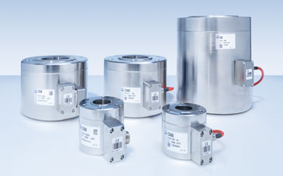
Designed for nominal (rated) forces from 200 kN to 10 MN, the C6B force transducer is used in harsh environments and dynamic applications. (Image: HBM)

About HBM Test and Measurement
Founded in Germany in 1950, Hottinger Baldwin Messtechnik GmbH (HBM Test and Measurement) is today the technology and market leader in the field of test and measurement. HBM’s product range comprises solutions for the entire measurement chain, from virtual to physical testing. The company has production facilities in Germany, USA, China and Portugal and is represented in over 80 countries worldwide.

