Precision in Weighing: The New PW15AHY Single Point Load Cell from HBM with a Ratio of Minimum Verification Interval of 25,000

- Accuracy class C3 (multi-range), Y = 25,000
- For maximum capacities between 10 and 100 kg
- Degree of protection IP68/69k, metal encapsulation

HBM has expanded its portfolio of legal for trade load cells in the SP4 standard dimensions: The new PW15AHY single point load cell has a ratio of minimum verification interval (Y) of up to 25,000 and allows weighing processes in the highest possible resolution.

The PW15AHY is typically implemented in automatic weighing systems in industrial settings, in shop-counter scales, or in other applications with a wide measuring range. The single point load cell possesses a stable measuring body made of stainless steel, a protection level of IP68/IP69k, as well as hermetic metal casing. This ensures reliable measurement results even under adverse conditions, or when the load cell is used in areas with constantly high levels of humidity. Like other HBM load cells, the PW15AHY relies on 6-wire technology, guaranteeing high signal stability.

Versatile and simple to integrate
PW15AHY is available with four maximum capacities (10, 20, 50 and 100 kg) and is designed in accordance with the industry-specific standard dimensions that significantly facilitate the integration into existing systems. The load cell is also available with a connector plug (PW15PHY).
For further information about the product visit: https://www.hbm.com/pw15ahy
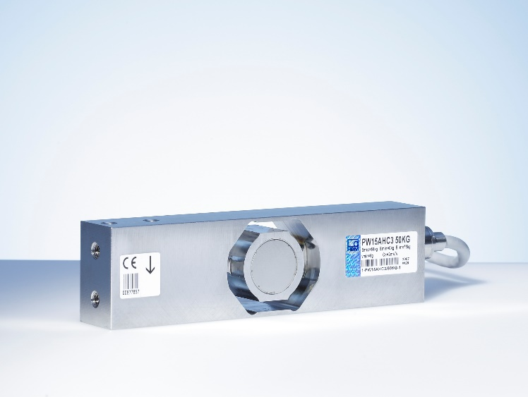
PW15AH is now also available with a minimum verification interval (Y) of 25,000 (Image: HBM)

About HBM Test and Measurement
Founded in Germany in 1950, Hottinger Baldwin Messtechnik GmbH (HBM Test and Measurement) is today the technology and market leader in the field of test and measurement. HBM’s product range comprises solutions for the entire measurement chain, from virtual to physical testing. The company has production facilities in Germany, USA, China and Portugal and is represented in over 80 countries worldwide.

